**Keyboard Interfacing**

**1. Introduction**

* A keyboard is an input device that allows users to send data or commands to an embedded system or a microcontroller.
* In embedded systems, instead of using a standard QWERTY keyboard, a smaller matrix keypad is commonly used due to its compact design and low I/O pin requirement.
* Matrix keypads are typically numeric or alphanumeric keypads configured in 3x4, 4x4, or similar layouts.
* These keypads are extensively used in applications where numeric input or limited command control is required.
* Common systems using keypad interfacing include digital locks, vending machines, calculators, and ATMs.

**2. What is a Matrix Keyboard?**

* A matrix keyboard is a type of keypad where push-button switches are arranged in a grid or matrix format consisting of rows and columns.
* In a 4x4 matrix keypad, there are 4 rows and 4 columns, resulting in a total of 16 keys (4 x 4 = 16).
* Each key is placed at the intersection of a row and a column.
* When a key is pressed, it completes the connection between a particular row and column.
* This design allows multiple keys to be read using a small number of microcontroller pins. Instead of needing 16 pins for 16 keys, a 4x4 matrix requires only 8 pins (4 rows + 4 columns).

**3. Construction of a Matrix Keypad**

* A matrix keypad consists of a group of momentary push-button switches. These switches are arranged in such a way that each button connects one row line to one column line.
* The front side of the keypad has the keys marked with numbers, letters, or symbols.
* The back side has conductive paths laid out in a matrix format.
* The rows and columns are connected to a microcontroller using its general-purpose I/O (GPIO) ports.

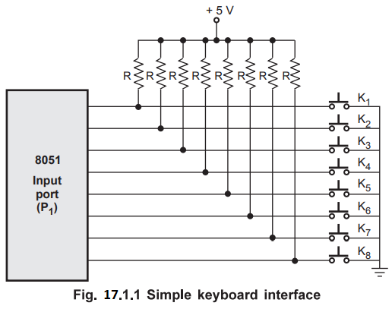

**4. Connection with Microcontroller**

* Matrix keypads are connected to the microcontroller’s I/O ports. A common microcontroller used in basic embedded systems is the 8051.
* The row lines of the keypad are connected to output pins of the microcontroller.
* The column lines are connected to input pins.
* For example, in the 8051 microcontroller, Port 1 (P1.0 to P1.7) can be used to connect all 8 lines of a 4x4 matrix keypad.
* Internal or external pull-up resistors may be used on the input pins to maintain a high logic level when no key is pressed.
* The microcontroller uses a scanning program to detect which key has been pressed by actively controlling the output pins (rows) and reading the input pins (columns).

**5. Working Principle – Key Scanning Method**

1. All row lines are set to HIGH initially (inactive state).
2. One row is pulled LOW at a time, and all columns are read.
3. If a key in the active row is pressed, the corresponding column line will read LOW.
4. By checking which row is LOW and which column reads LOW, the exact key pressed can be identified.
5. The process is repeated continuously for all rows to detect key presses in real time.
6. Return the key value to the main program.

**6. Circuit Diagram Description:** A typical 4x4 matrix keypad is interfaced with 8051 microcontrollers as follows:

* Row lines (R1 to R4) are connected to microcontroller output pins such as P1.0 to P1.3.
* Column lines (C1 to C4) are connected to input pins such as P1.4 to P1.7.
* The scanning algorithm is implemented in the software to detect which key (intersection of row and column) is pressed.
* The microcontroller reads the state of the columns after activating each row to identify the exact key.

**7. Applications of Matrix Keypad Interfacing**

* Digital door locks for entering secure passwords or codes.
* ATMs and point-of-sale (POS) machines for PIN entry and amount input.
* Embedded control panels in appliances like microwave ovens or washing machines.
* Calculators and handheld measurement devices requiring numeric inputs.
* Menu navigation systems in embedded user interfaces.

**8. Advantages of Matrix Keypad Interfacing**

* **Reduces I/O pin usage**: Instead of using one pin per key, the matrix structure significantly minimizes the number of I/O pins required.
* **Simple to design and integrate**: Matrix keypads are easy to connect and program, even for beginners in embedded systems.
* **Low cost**: The hardware is inexpensive and widely available.
* **Reliable operation**: With proper debouncing and scanning logic, key detection is accurate and stable.
* **Compact form**: Matrix keypads are physically small and suitable for compact embedded device designs.

**9. Limitations and Challenges**

* **Key bounce**: Mechanical keys produce noise during transitions, requiring debouncing.
* **Ghosting effect**: In some matrix configurations, pressing multiple keys may lead to incorrect detection if not properly handled.
* **Limited keys**: A matrix keypad is suitable for small input needs but not for applications needing full keyboards.
* **Constant polling**: The microcontroller must continuously scan the keypad, which may add CPU overhead in real-time systems.